

**NAMA: AHMAD SYAUQAN ASQALANI BIN AZHAM**

**NO.NDP: 23221022**

**TUGASAN:TUGASAN AMALI CSS**

**PENSYARAH: PUAN TG MUZLINA HANIM BINTI TG SEMARA**

**HOME PAGE**



**ABOUT PAGE**

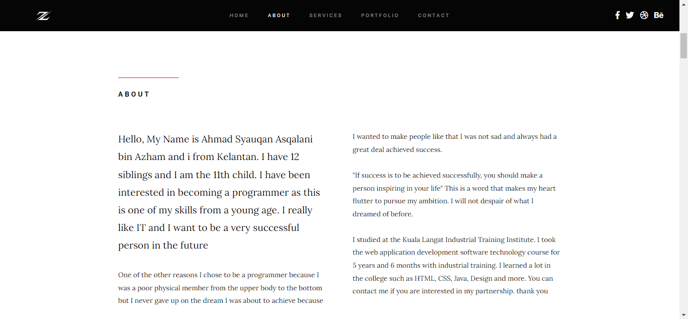

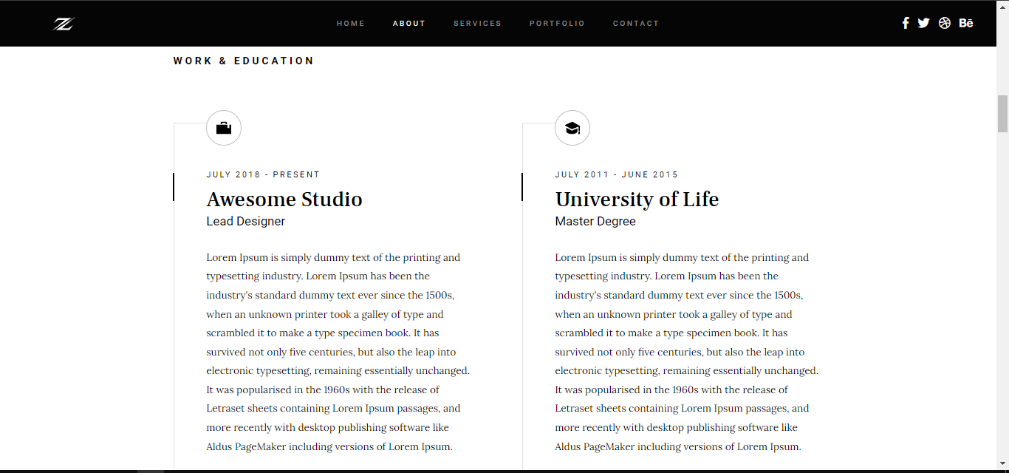

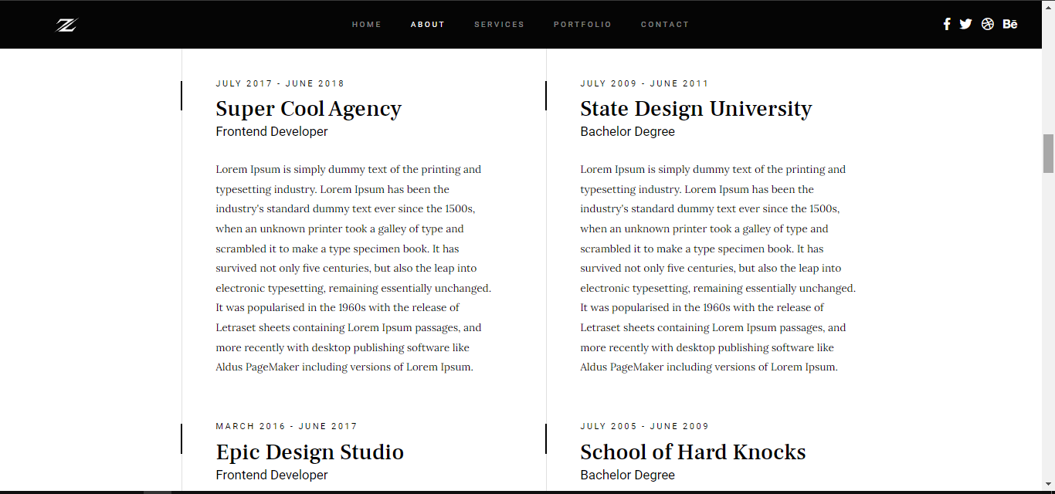

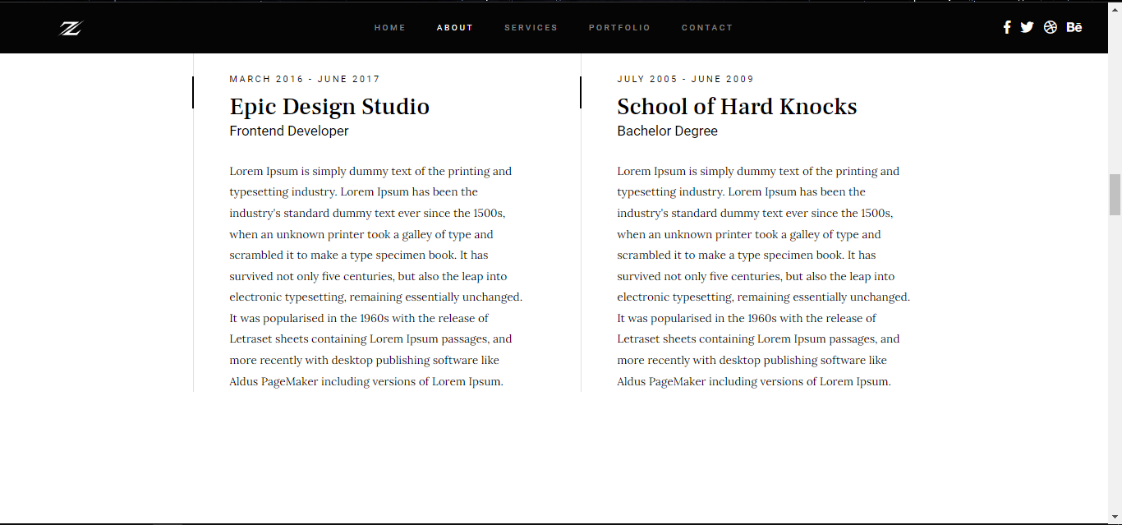

**SERVICE PAGE**

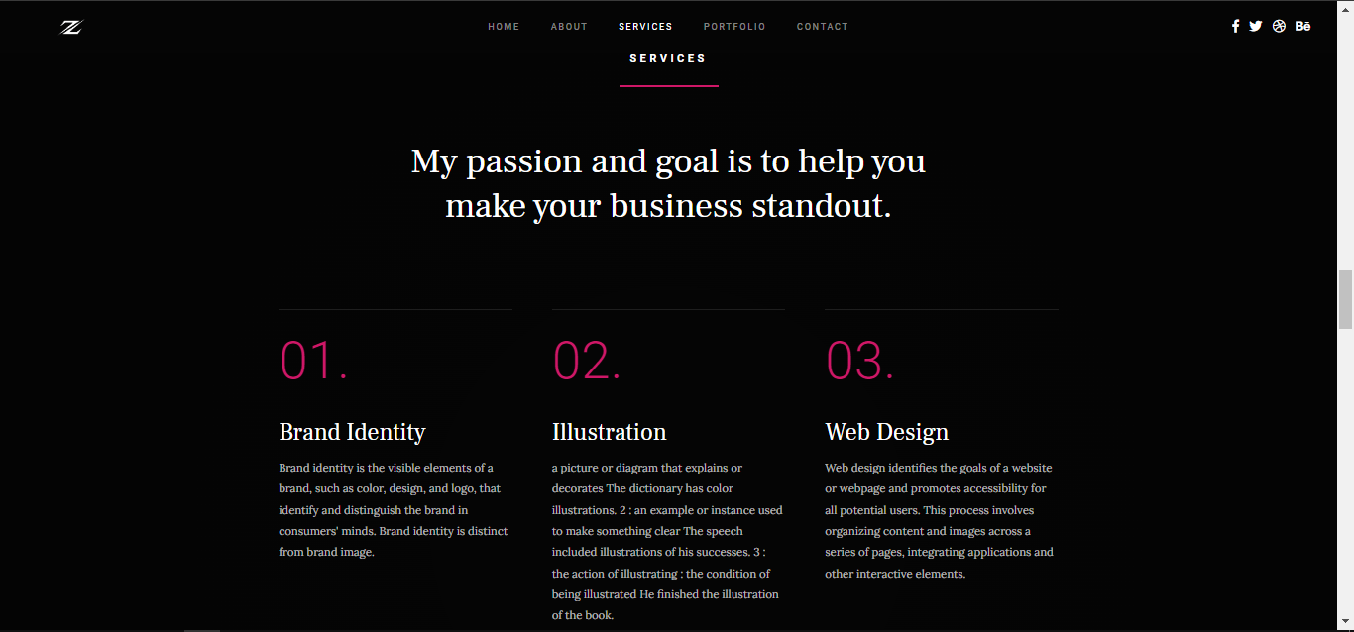



**PORTFOLIO PAGE**

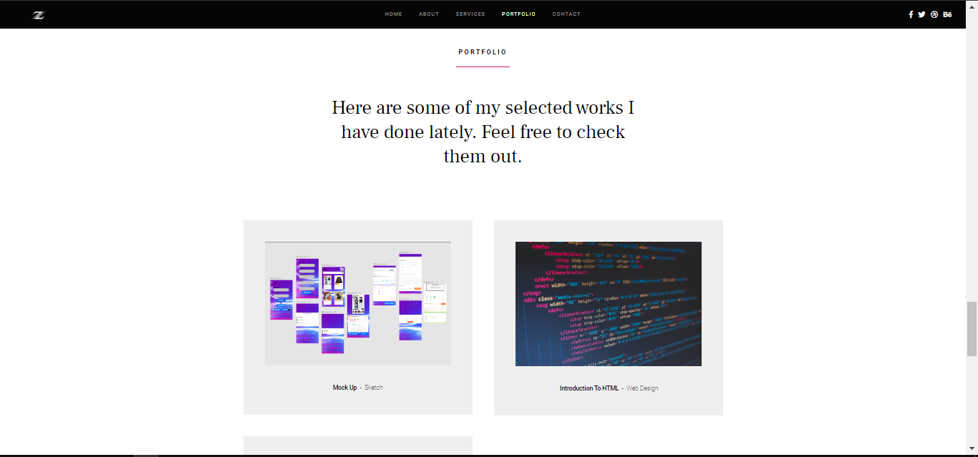

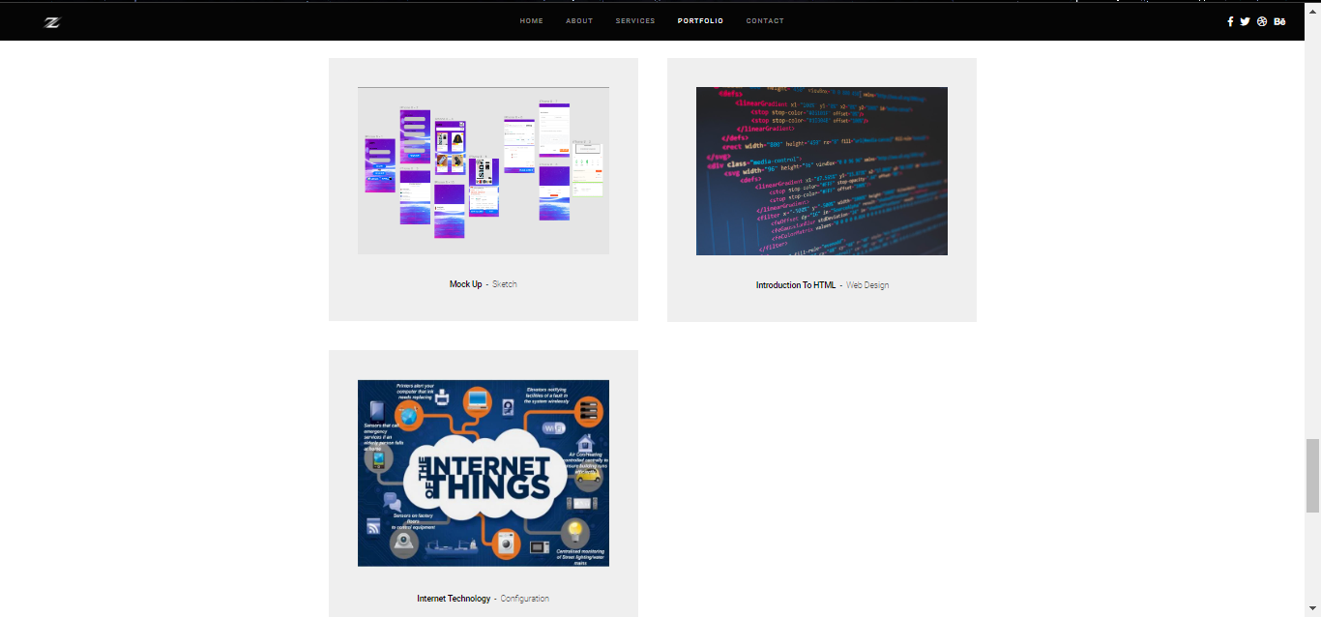

**CONTACT PAGE**

